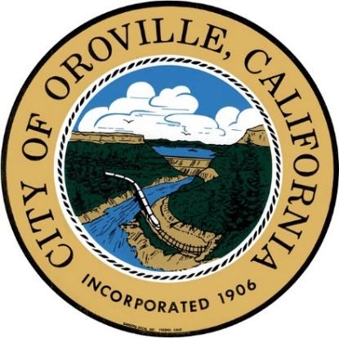**OROVILLE EXECUTIVE COMMITTEE**

Oroville City Hall – Fireside Room

1735 Montgomery Street

Oroville, CA. 95965

**October 10, 2019**

**REGULAR MEETING**

**OPEN SESSION 10:30 AM**

**Agenda**

**REQUESTS TO ADDRESS COMMITTEE**

Council has established time limitations of two (2) minutes per speaker on all items. **(California Government Code §54954.3(b))**. Pursuant to Government Code Section 54954.2, the Committee is prohibited from taking action except for a brief response to statements or questions relating to a non-agenda item.

**CALL TO ORDER / ROLL CALL**

Committee Members: David Pittman, Eric Smith and Chuck Reynolds

**OPEN SESSION**

1. Pledge of Allegiance

**PUBLIC COMMUNICATION – HEARING OF NON-AGENDA ITEMS**

This is the time to address the Committee about any item not listed on the agenda. If you wish to address the Committee on an item listed or not listed on the on the agenda, please follow the directions listed above.

**REGULAR BUSINESS**

**1. DISCUSSION WITH THE YMCA REGARDING THE POTENTIAL OF AN EXCLUSIVE RIGHTS CONTRACT FOR THE MUNICIPAL AUDITORIUM**

The Executive Committee will meet with the YMCA to discuss the terms presented by the YMCA and provide direction to staff.

**ADJOURN THE MEETING**

The meeting will be adjourned.

*Accommodating Those Individuals with Special Needs* – In compliance with the Americans with Disabilities Act, the City of Oroville encourages those with disabilities to participate fully in the public meeting process. If you have a special need in order to allow you to attend or participate in our public meetings, please contact the City Clerk at (530) 538-2535, well in advance of the regular meeting you wish to attend, so that we may make every reasonable effort to accommodate you. Documents distributed for public session items, less than 72 hours prior to meeting, are available for public inspection at City Hall, 1735 Montgomery Street, Oroville, California.