SUPPLEMENTAL BENEFITS FUND STEERING COMMITTEE
(SBF)

NOTICE OF FUNDS AVAILABLE (NOFA)

2021 NOFA GUIDELINES &
Application

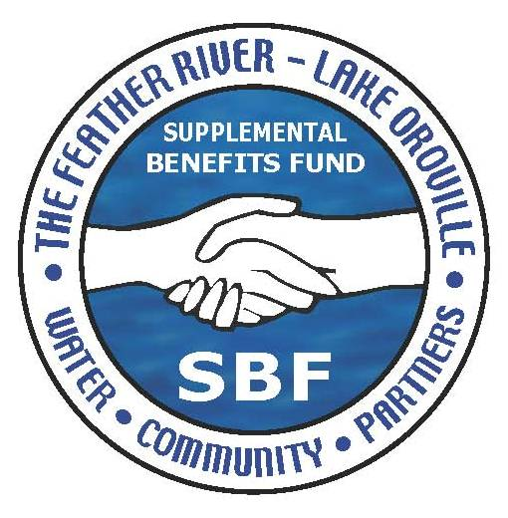

SUPPLEMENTAL BENEFITS FUND

CITY OF OROVILLE FUND ADMINISTRATOR

Note: A guide to acronyms used in the
grant process can be found on page 19

Funding provided by

STATE WATER CONTRACTORS (SWC)
&
STATE OF CALIFORNIA DEPARTMENT OF WATER RESOURCES (DWR)

As part of the Settlement Agreement for Licensing of the Oroville Facilities FERC Project No. 2100

TABLE OF CONTENTS

Section | Topic | Page Number(s)
 | Contact Information  Workshop Information  Mailing Information | 3
 | Introduction & Overview  Grant Classification & Allocation | 4
I. | Eligible Applicants  Potential Project Areas | 5 – 6
II. | General Grant Information | 7 - 8
III. | The Project Application Submittal | 9 – 11
IV. | Appendices (A –L)  - Legal Notice  (B) List of Acronyms  (C) SBF Vision Statement  (D) Regional Fund Strategic Plan  (E) SBF Steering Committee  (F) Feather River Conceptual Plan  (G) Prior SBF Funding  (H) Project App. Requirements  - FERC Boundary  (J) Accounting/Audit Requirements  (K) Appeal Process  (L) Formal Application | 12  13  14  15  16  17  18  19 - 20  21  22  23-24  25  26 - 35

GENERAL Information

City of Oroville
Supplemental Benefits Fund
Fund Administrator
1735 Montgomery Street
Oroville, Ca 95965

Questions may be directed to:

SBF Program Specialist
Phone: (530) 538 - 2518
Email: sbf@cityoforoville.org
Website: www.cityoforoville.org

The Supplemental Benefits Fund SBF Steering Committee will
hold a grant application zoom workshop to explain the
application process and program requirements.

The recommended zoom workshop will be held on:

Thursday, February 4, 2021, from 3:00 P.M. until 4:00 P.M.

Please RSVP to: (530) 538-2535 or email at SBF@cityoforoville.org
NO LATER THAN: January 27, 2021

SEND Completed Applications by 4:00 P.M. (PDT) THURSDAY, MARCH 22, 2021
to:

City of Oroville
Supplemental Benefits Fund
Fund Administrator
Attention: SBF Program Specialist
1735 Montgomery Street
Oroville, Ca 95965

faxed or EMAILED APPLICATIONS will not be accepted

- INTRODUCTION AND OVERVIEW

Supplemental Benefits Fund

The Supplemental Benefits Fund (“SBF”), the result of a Settlement Agreement signed by multiple parties associated with the re-licensing of the Oroville Facilities (FERC Project No.2100), will make available up to approximately $61 million (in nominal dollars) over the next 30 to 50 years, depending on the term of the license when approved by the Federal Energy Regulatory Commission (“FERC”).

2021 Notice of Funds Available Determination

Pending the approval of the FERC licensing of the Oroville Facilities advance funds have been made available by DWR to the SBF for Administration, Project requests and Marketing Community Benefit requests that meet the requirements established by the SBF Steering Committee.

A determination was made on, December 2, 2020, by the SBF Steering Committee that $200,000 would be made available and offered through the 2021 Notice of Funds Available (“NOFA”). The SBF Steering Committee’s approval provided that funds be offered in the following category which is consistent to those approved in the Regional Fund Strategic Plan (“RFSP”).

Project Fund $200,000

Projects Fund ($200,000 available) is intended to directly fund projects that are consistent with the Settlement Agreement and SBF Mission & Vision Statements. To be considered for funding, application requests must be within one, or more, of the six “reaches” as defined in the Feather River Conceptual Plan a Vision for the Low Flow Channel of the Feather River (FRCP), (approved by the SBF Steering committee in 2017) The “reaches” are defined as:

Reach 1: Diversion Pool Area
Reach 2: Fish Barrier Pool Area
Reach 3: Historic Downtown District
Reach 4: Riverbend Park Area
Reach 5: Oroville Wildlife Area
Reach 6: Thermalito Forebay Area

The intent of the FRCP, as envisioned and funded by the SBF Steering Committee, was to consolidate into a single document all the best ideas from existing Oroville plans and includes future river-related projects that might best improve the quality of life and stimulate economic development in the greater Oroville Region. The FRCP also strengthens the definition of the Feather River’s “riverscape” and its distinctive identity. It is in the interest of the community that approved projects gain the fullest of the benefits intended by the Settlement Agreement, by focusing and leveraging projects approved by the SBF into successful, river-orientated public-private partnerships and other potential collaborative opportunities.

ELIGIBLE APPLICANTS

- Local Government Agencies
- Non-profits
- and others

Potential Project Areas

- Project Fund: as defined by the Feather River Conceptual Plan, A Vision for the Low Flow Channel of the Feather River (Click here for a full image of the map)

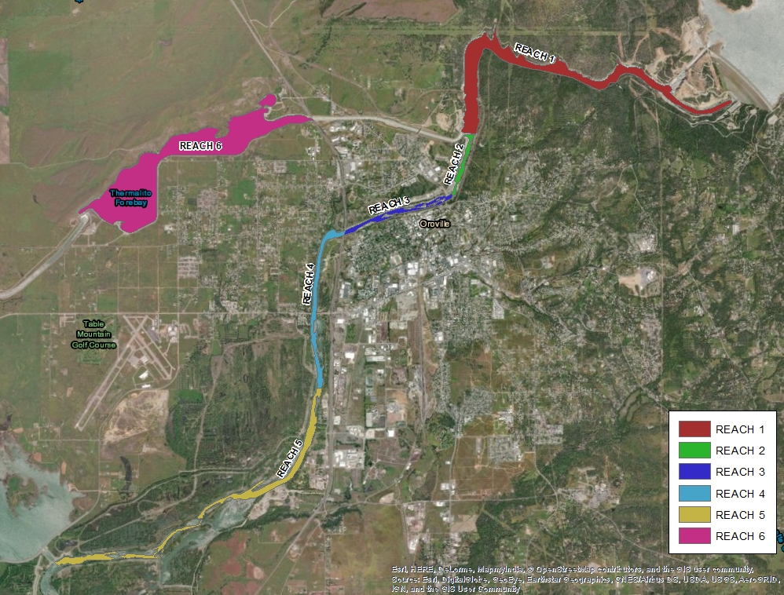

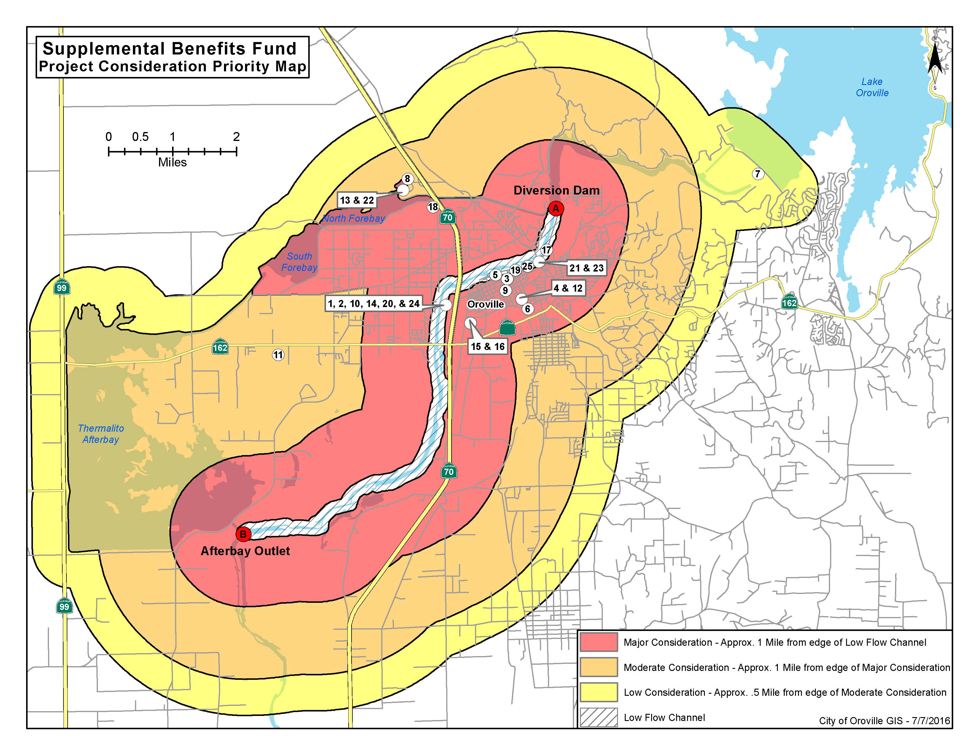

II. GENERAL GRANT INFORMATION

The RFSP does not include a set of recommended SBF projects; rather it establishes a process for selecting and funding approved projects over time. During the initial stakeholder meetings in 2004, a list was developed from community input and used as a basis of negotiating the Settlement Agreement. The list included projects totaling $111,384,543. Half of that amount plus funds previously provided by DWR for Phase I and II of Riverbend Park totaled $61,270,000 which was used to establish the base of potential funds to be made available, assuming issuance of a fifty-year license, to the SBF for projects and administration.

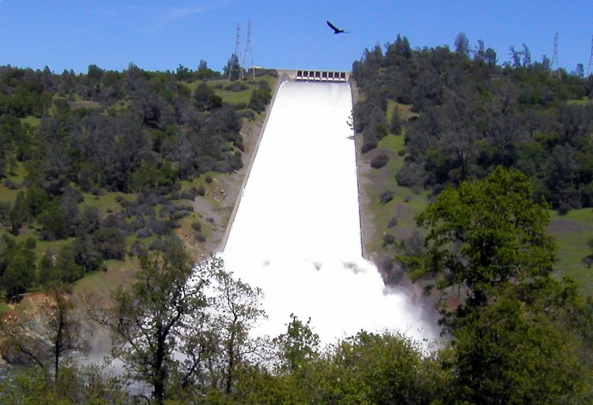

Water funds the SBF

III. THE PROJECT APPLICATION AND SELECTION PROCESS

    - Eligibility

All projects that are consistent with the SBF Vision Statement, Appendix (C) page 19, and are located outside of the Oroville Facilities boundary, (FERC boundary) are eligible. At DWR’s sole discretion, and subject to additional approvals, the SBF may be used to support projects located within the Oroville Facilities FERC boundary. (see map on page 26)

    - Operating Expense Considerations

In consideration of the long-term maintenance and operation expenses of a project, project applicants must present a plan, if appropriate, that addresses maintenance and operations.

C. Additional Information

To create public confidence and transparency along with a technically sound selection process given the wide range of potential projects, the competing interests, and the limited funding available, the established formal decision-making process includes:

- Provides assistance to applicants proposing projects (Workshop, Thursday, February 4, 2021)
- Adheres to a set of clear screening criteria (to determine whether a project even qualifies)
- Allows the SBF Steering Committee to select projects for funding
- Contains a process of annual appropriation of available funds, consistent with project priorities

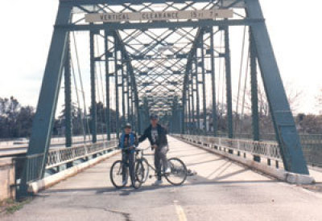
Historic Table Mountain Bridge over the Feather River

- Project Application Submittal

Note: The section titles used by Applicants to represent Project elements should be consistent throughout the application, including scope, timeline, and cost estimates.

The Grant Application is comprised of the following sections:

- Applicant Information
- Description of Project
- Project Selection Criteria
- Consistency with SBF Goals
- Ability to Pay Back Funding (if applicable)
- Project Readiness
- Funding for Operations and Maintenance
- Nexus to the Feather River
- Potential to Enhance Local Jobs
- Consistency with other Capital Improvement Plans
- Enhance “Sustainable Development” Objectives
- Enhance Quality of Life for Local Residents and Attracting Visitors
- Additional Information (studies, data, or other information that might help the SBF Steering Committee evaluate the value of the proposed project

The complete application is in Appendix M, pages 31 - 42 a printable copy of the application is available at www.cityoforoville.org SBF information and forms. If using additional pages to complete the application, please use the appropriate titles (on each page) as listed above.

- SBF Review of Applicant’s Project (Screening Process)
The next step involves a technical review of the submitted application considering basic Project Submittal Requirements, SBF Goals and Objectives, and a set of Screening Criteria. On the basis of these considerations, a decision would be made whether or not an application meets minimum requirements. If not, the application would be respectfully rejected. This Initial Screening Process will eliminate projects that lack merit given the six following considerations:
- Completeness of the Proposal.
- Consistency with SBF Goals.
- Feasibility study, conceptual plans and specifications.
- Project Readiness (including availability of matching funds).
- Availability of operation and maintenance funding (as may be required).
- Consistency with the Feather River Concept Plan and the DWR Recreation Management Plan and other local plans and programs.
An applicant whose Project Concept application does not meet the Initial Screening Criteria has the right to appeal to the SBF Steering Committee, based upon appeal procedures established by the SBF Steering Committee. (see Appendix L, page 30)
3. Staff Assembly and Submittal of Proposed Projects
SBF staff is available for direction to ensure applications are complete and ready for consideration. SBF staff will assemble all project proposals together and prepare packages for the SBF Steering Committees review.
Scoring Project Applications by the SBF Steering Committee will allow the establishment of a ranked order of based on objective criteria regarding their relative merit. Standards of measurement that are objective, applicable, and quantifiable have been established, including: The evaluation criteria are:
- If appropriate, the ability to pay back funding to the SBF from revenues derived from investment.
- “Nexus” to the Feather River.
- Consistency with local plans.
- Potential to enhance local jobs or create training opportunities.
- Ability to enhance the quality of life for residents in the region and attract visitors.
The technical scoring of projects will be completed by the Steering Committee based upon the application submitted and a formal presentation by the project applicants.
A score will be assigned based on the range of values for each criterion. Another aspect of the Project Evaluation Criteria is their relative importance. They may all have equal weight but more likely some may be more important than others. For this reason, the criteria themselves placed in rank order, the most heavily weighted first. A value is given to each, given their relative importance.

4. SBF Steering Committee Project Selection Process
The SBF Steering Committee will individually be provided a copy of the application, and the Executive Summary prior to the applications presentation at a Public Meeting. This provides time for the SBF Steering Committee members to review the request and formulate questions that they might have.
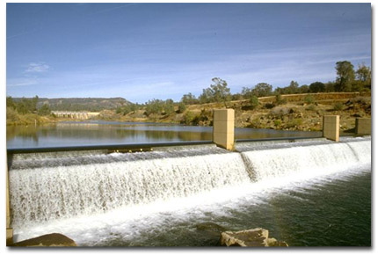
Diversion Dam near the Feather River Fish Hatchery

Appendices

Appendix A: Legal Notice

Appendix B. List of Acronyms

Appendix C. SBF Vision Statement

Appendix D: Regional Fund Strategic Plan

Appendix E: SBF Steering Committee

Appendix F: Feather River Conceptual Plan, A Vision for the Low Flow Channel of the Feather River (2017)

Appendix G: Prior SBF Funding

Appendix H: Project Application Requirements

Appendix I: FERC Boundary

Appendix J: Accounting/Audit Requirements

Appendix K: Appeal Process

Appendix L: Formal Application

Appendix A

- 2021 NOFA Legal Announcement

------------------------------------------------------------------------------------------------------------

SUPPLEMENTAL BENEFITS FUND (SBF)

1735 MONTGOMERY STREET -- OROVILLE, CA 95965-4897
(530) 538-2518 Fax (530) 538-2468

NOTICE OF FUNDS AVAILABLE (NOFA)
nofa release date: Thursday January 20, 2021

Applicant Workshop: Thursday, February 4, 2021
(Zoom Q & A: 3:00 to 4:00 P.M.)

The Supplemental Benefits Fund (SBF) Steering Committee announces a Notice of Funds Available (NOFA) for the 2021 funding cycle. A total of $200,000 in funding will be made available by the SBF for the following categorical allocations:

- Project Fund: $200,000

SBF Mission Statement

Reconnecting the beauty and diversity of the Feather River with the community will be the primary component of projects approved by the Supplemental Benefits Fund Steering Committee. The approved projects will provide additional recreational opportunities and economic benefits that enhance
the lifestyle of the Oroville Region.
(Excerpt from the SBF/Regional Fund Strategic Plan)

The NOFA, Grant Guidelines and application are available for review at:

- Oroville City Hall
1735 Montgomery Street Oroville, CA 95965

- Electronically at: www.cityoforoville.org (City Services/SBF)

Written applications must be delivered as detailed in the guidelines and received by the City of Oroville, 1735 Montgomery Street, Oroville, CA 95965 no later than 4:00 P.M. (PST) on Thursday, March 22, 2021.
______________________________________________________

Additional information about the Supplemental Benefits Fund is available at:

www.cityoforoville.org
Email: SBF@cityoforoville.org (530) 538-2518

APPENDIX B List of Acronyms

DWR Department of Water Resources
EPS Economic & Planning Systems, Inc.
FERC Federal Energy Regulatory Commission
FRCP…………………………………………………………Feather River Conceptual Plan,
……………………………………. A Vision for the Low Flow Channel of the Feather River
FRRPD Feather River Recreation and Parks District
FTE Full-time equivalent
NOFA .............. Notice of Funds Available
RFP Request for Proposals
RFSP...................................................................................Regional Fund Strategic Plan
RLF Revolving Loan Fund
RMP Recreation Management Plan
SBF Supplemental Benefits Fund
SBF Rules of Governance SBF Steering Committee Rules of Governance
Settlement Agreement Settlement Agreement for Licensing the Oroville Facilities

Helpful Electronic Resources
__________________________________________________________________

City of Oroville: www.cityoforoville.org (SBF Documents)
Feather River Recreation Park District: www.frrpd.com
Department of Water Resources: www.water.ca.gov
Department of Fish & Game: www.dfg.ca.gov
State Water Contractors: www.swc.org
Oroville Area Chamber of Commerce: www.orovilleareachamber.net

Appendix C SBF VISION STATEMENT

NOTE: The SBF Steering Committee approved the following Vision Statement on July 7, 2010, to assist applicants in understanding approval consideration values.

Reconnecting the beauty and diversity of the Feather River with the community will be the primary component of projects approved by the Supplemental Benefits Fund SBF Steering Committee. The approved projects will provide additional recreational opportunities and economic benefits that enhance the lifestyle of the Oroville Region.

The following rules of governance are provided for applicants requesting consideration for grant funding from the Supplemental Benefits Fund:

- Major consideration: The applicant shall provide a compelling presentation as to how the proposed project will assist in mitigating what was lost by the construction of the Oroville Dam Facilities (FERC Project No. 2100). The application shall take into consideration the various existing City of Oroville, Feather River Recreation and Park District plans, the Settlement Agreement for licensing of the Oroville Facilities FERC Project No. 2100, and other regional plans. (Refer to page 3-2 of the RFSP).

- Moderate consideration: The applicant should provide a meaningful connection to existing, or planned, facilities and projects. The application should also be in, or near, the low-flow channel of the Feather River (defined in Figure 1-1 of the RFSP) and assist in making the Oroville Region a Northern California destination.

- Low consideration: The applicant’s proposed project may be away from the low-flow channel of the Feather River, not connected to existing, or planned, facilities and projects, be unique, or a non-profit venture within the Oroville Region including areas under FERC jurisdiction.

APPENDIX D Regional Fund Strategic Plan (executive summary)

On April 22, 2010, the SBF Steering Committee approved the Regional Fund Strategic Plan (“RFSP”), which assures that approval of projects remains in sync with the intent of the SBF. The SBF Steering Committee identified the following mission statement for the SBF:

“Investing in recreational and related projects with a nexus to the Feather River to improve the quality of life and stimulate economic development in the Oroville region.”

Distribution of SBF funding will take place within the context of other ongoing processes and events. As stated by the SBF Steering Committee, “the intent of the RFSP is to get the most economic investment return from the approved projects as well as ensuring that a decorum of fairness exists in project selection.”

The Regional Fund Strategic Plan calls for projects to be consistent with the Department of Water Resources 2006 Recreation Management Plan. In addition, consideration as to how the proposed project will interface with the following Oroville Region supporting agencies should be a part of the application:

- City of Oroville (Infrastructure, safety, neighborhood leisure parks, trails, open space and museums).
- Department of Fish and Game (Fish hatchery and environmental mitigation).
- Department of Water Resources (Lake, River and Recreation Management Plan).
- Feather River Recreation and Park District (Parks, trails and recreation programs).
- Oroville Area Chamber of Commerce (Tourism and economic development).

Appendix E: SBF STEERING Committee (executive Summary)

SBF funded projects are selected by the SBF Steering Committee, comprised of appointed voting representatives from the Feather River Recreation and Parks District (FRRPD) Board of Directors and representatives from the City of Oroville City Council. Advisory representatives from American Rivers, the State Water Contractors, Department of Water Resources, and the Oroville Area Chamber of Commerce may provide comments but are not included in the voting decision. The City of Oroville also serves as the Fund Administrator, whose duties include ensuring performance of the SBF and overseeing administrative duties to operate the SBF on an ongoing basis. Upon approval of the FERC license, the State Water Contractors, in partnership with the Fund Administrator and SBF Steering Committee, also have the additional responsibility of actively pursuing grant opportunities beyond SBF funding.
At the start of each budget cycle, the SBF Steering Committee will distribute anticipated funding into one or more of the following categories:

- Administration
- SBF Projects
- Large Award Fund
- Revolving Loan Fund
- Marketing and Community Benefit Fund
- Marketing/Chamber of Commerce Fund
- Contingency Fund

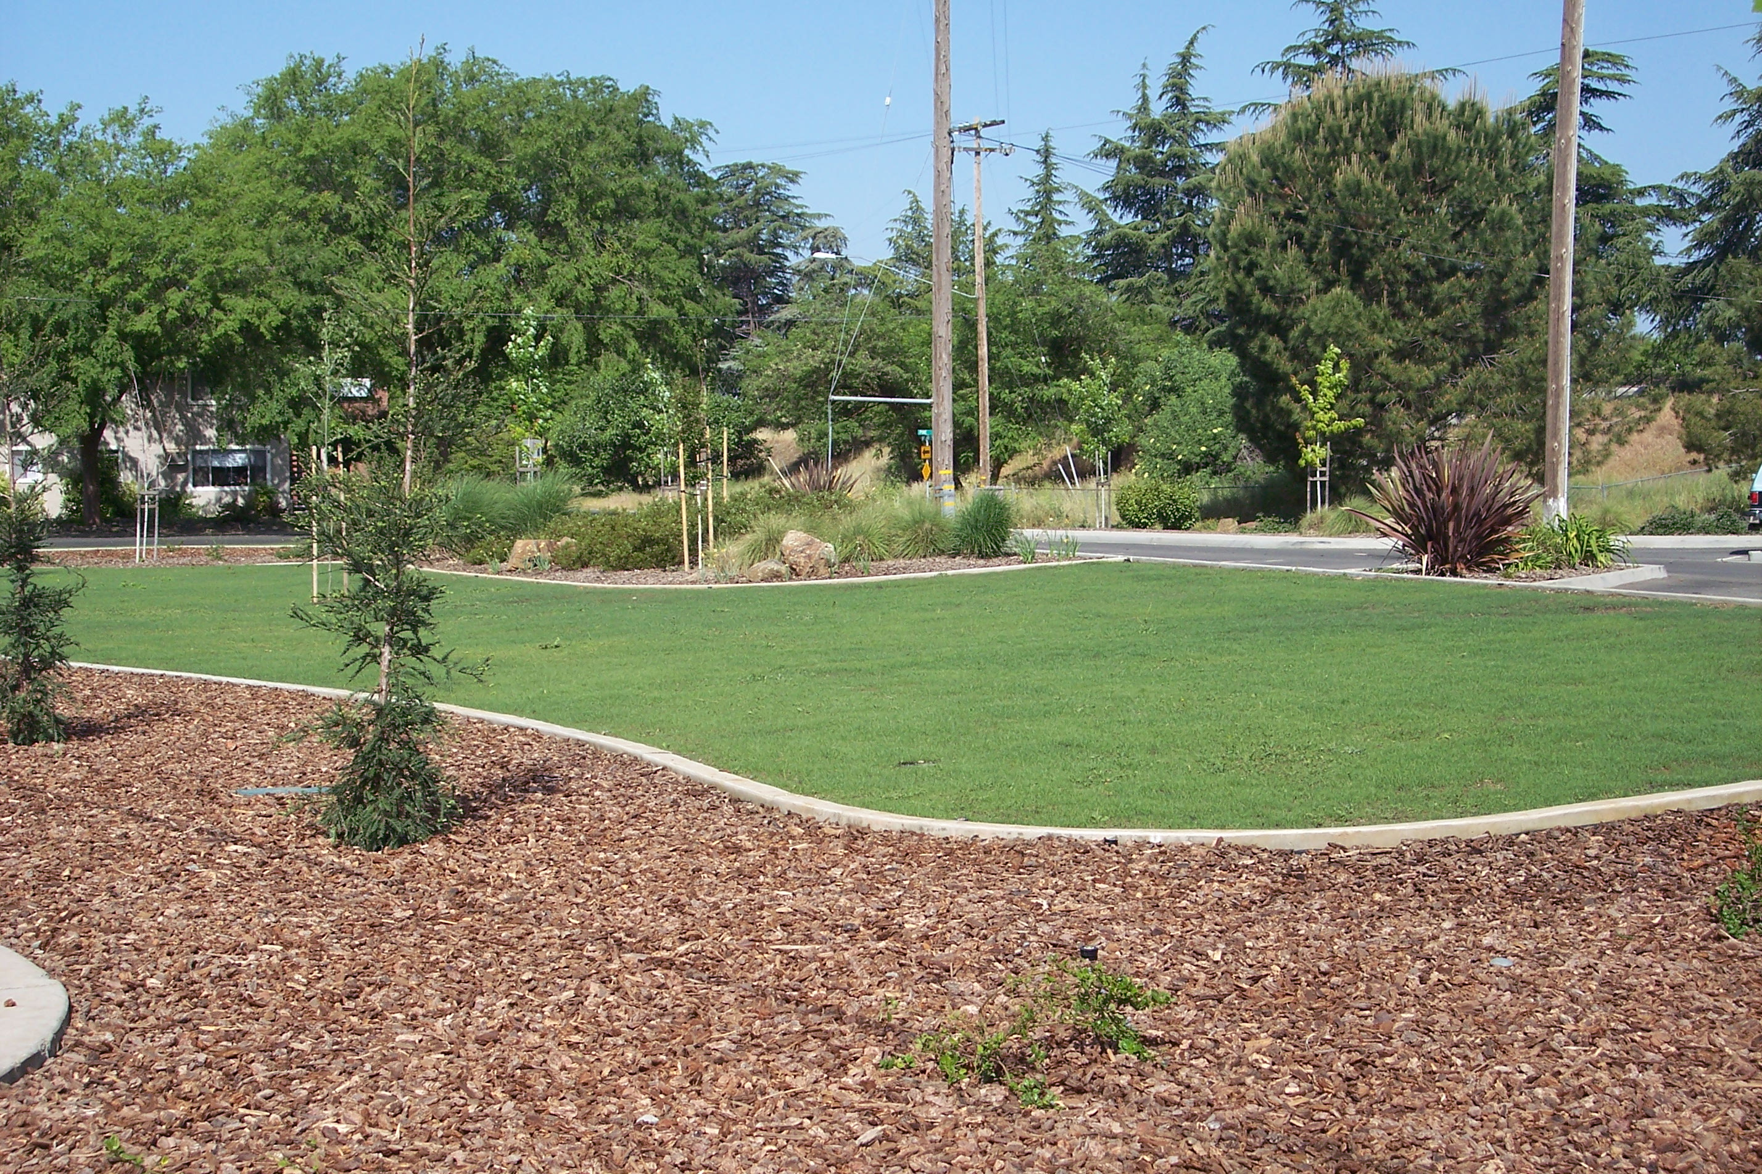

City of Oroville Chinese Brick Building Landscape Project

Appendix F: Feather River Conceptual Plan, A Vision of the Low Flow Channel of the Feather River

The Feather River Conceptual Plan (FRCP) was envisioned by the SBF Steering Committee as a way to consolidate into a single document all the best ideas from existing Oroville plans and includes future river -related projects that might best improve the quality of life and stimulate economic development in the Greater Oroville Region. Many projects might be collaboratively and synergistically implemented in coordination with the Department of Water Resources’ implementation of requirements in and along the Feather River which are part of the Oroville Project (FERC No. 2100).
The FRCP provides detailed information and suggestions for six specific “reaches” along the Feather River:
Reach 1: Diversion Pool Area
Reach 2: Fish Barrier Pool Area
Reach 3: Historic Downtown District
Reach 4: Riverbend Park Area
Reach 5: Oroville Wildlife Area
Reach 6; Thermalito Forebay Area
The FRCP communicates a vision for each river reach by providing an umbrella strategy for the Feather River as a whole. The FRCMP is available by clicking here and is divided into the following chapters:
Chapter1: Introduction and Background
Chapter 2: The Master Plan Development Process
Chapter 3: Project Recommendations
Chapter 4: Economic Development Considerations and Strategies
Chapter 6: Priorities and Next Steps
The appendices of the FRCP provide summaries of the stakeholder meetings including an extensive list of potential (suggested) projects, other existing plans leveraged in this effort and other existing conditions summaries of the Plan (reaches) area.
Appendix G: Prior SBF Funding & Commitments

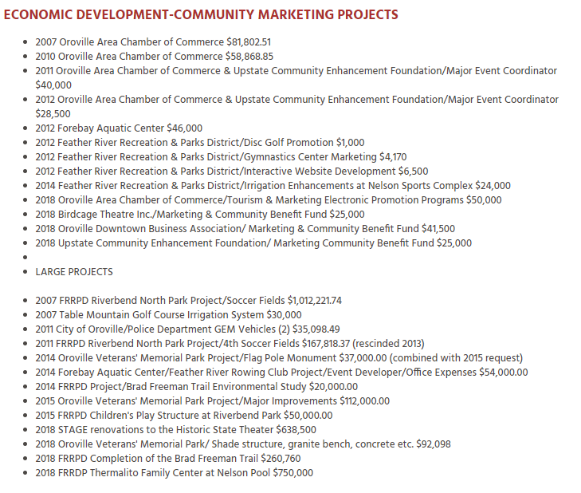

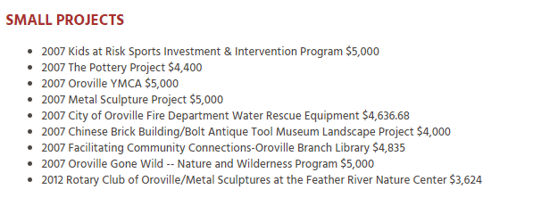
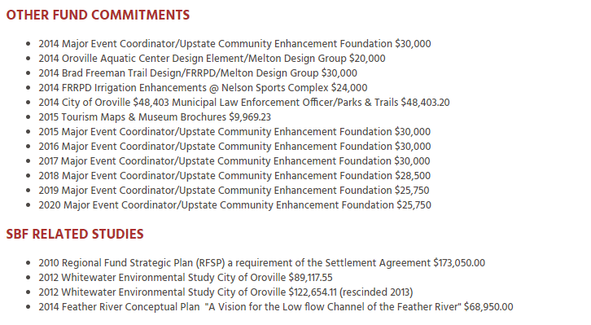

Appendix H Project Application Requirements

This guide is provided to assist you in completing the application. All screening criteria must be addressed to allow the application to proceed forward in the process.



Initial Screening Criteria: (To be considered, Applicants must have the following mentioned items.)

- Completeness of Proposal required
- Consistency with SBF Goals required
- Project readiness required
- Availability of O&M funding required
- Consistency with the SBF FRCP required
- Consistency with DWR RMP recommended
- Consistency with City of Oroville WF Plan recommended
- Consistency with FRRPD Master Plan recommended

Additional Criteria: (Once Staff has determined if the applicant has met the initial screening criteria, the SBF Steering Committee will evaluate the application based on the following additional criteria categories.)

- Nexus to the Feather River required
- Potential to Enhance Local Jobs recommended
- Consistency with Local Plans required
- Enhancement of “Sustainable Development” Objectives recommended
- Ability to Enhance Quality of Life for Residents recommended
And Attract Visitors

APPENDIX I

ferc boundary map/low flow channel of the feather river

The Federal Energy Regulatory Commission (FERC) established boundaries (yellow lines) for the Oroville Facilities Project No. 2100 which includes the Oroville Dam, Hyatt Hydrogeneration Plant, Thermalito Diversion Pool, Thermalito Forebay, Thermalito Pumping and Generating Plant and other related Feather River activities. Projects approved by the Supplemental Benefits Fund Steering Committee are to be outside of the FERC boundary. At DWR’s sole discretion and subject to FERC approval, Supplemental Benefit Funds may be used to support projects located within the Oroville Facilities’ boundary, but which are not within the jurisdiction of FERC. (Appendix B of the Settlement Agreement for the licensing of the Oroville Facilities, March 2006)

map of the Oroville Facilities (green shading denotes FERC boundaries)

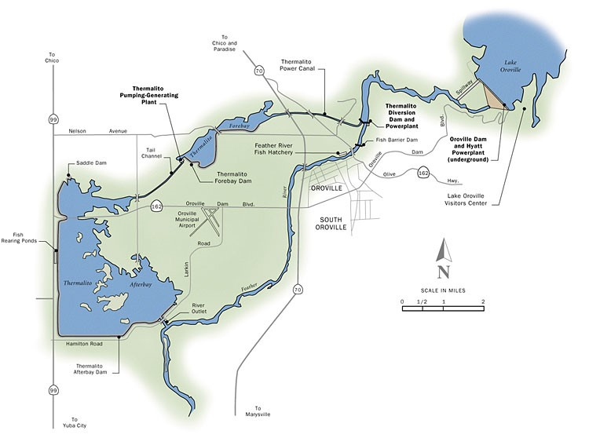
Appendix J

ACCOUNTING AND AUDIT REQUIREMENTS
GRANT ADMINISTRATION

A. Audit Requirements

SBF Projects are subject to audit by the SBF Steering Committee, and or, the Fund Administrator for three (3) years following the final payment of grant funds. If your Project is selected for audit, you will be contacted in advance. The audit shall include all books, papers, accounts, documents, or other records of the Grantee, as they relate to the Project for which the funds were granted.

B. Accounting Requirements

The Grantee must maintain an accounting system that:

- Accurately reflects fiscal transactions, with the necessary controls and safeguards.
- Provides a good audit trail, including original source documents such as purchase orders, receipts, progress payments, invoices, time cards, canceled checks, etc.
- Provides accounting data so the total cost of each individual project can be readily determined.

C. Records Retention

Project records must be retained for a period of three (3) years after final payment is made by the Fund Administrator. All project records must be retained by the Grantee at least one (1) year following an audit. Grantees are required to keep source documents for all expenditures related to each grant for at least three (3) years following project completion and one (1) year following an audit. A Project is considered complete upon receipt of final grant payment from the Fund Administrator.

D. Payment of Grant Funds

Approved grants require a fully executed Grant Agreement between the Fund Administrator (City of Oroville) and the Grantee. The SBF will provide reimbursement for costs of an approved Grant Agreement as stipulated. All payments are paid on a reimbursable basis. Grantee’s will submit an invoice with appropriate proof of payment (canceled checks, etc.) The Fund Administrator will verify submittals and forward them to the California State Department of Water Resources. Once funds are received by the Fund Administrator the Grantee will be issued a check.

  - Site Visits

The SBF Project Coordinator will make periodic visits to the Project site, including a final inspection of the site. The SBF Project Coordinator will determine if the work is consistent with the approved SBF Project Scope and ensure compliance with signage requirements that identify the project as an SBF Grant.

  - Loss of Funding

The following are examples of actions (some or all may apply) that may result in the Grantee’s loss of funding.

- Grantee fails to sign the Grant Contract within the thirty-day time period as specified in the Grant Contract.
- Grantee withdraws from the grant program.
- Grantee loses a willing seller(s) or property cannot be acquired at Fair Market Value.
- Grantee fails to complete the funded Project within the agreed upon time frame.
- Grantee fails to submit all documentation within the time periods specified in the Grant Agreement.
- Grantee is unable to acquire CEQA compliance or any required permits.
- Grantee changes Project Scope, without prior approval from the SBF Steering Committee.

If loss of funding occurs the grantee must return any advanced funds, plus accrued interest (at the current saving rate offered by banks) to the SBF.

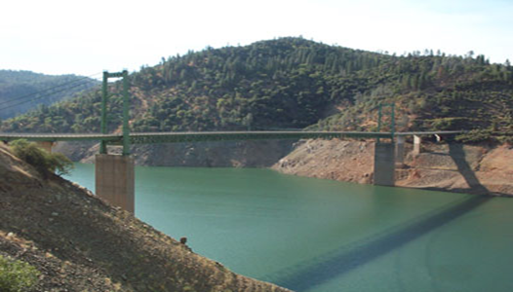
162 Bridge across Lake Oroville

Appendix K

The 2021 NOFA Appeal Process

As part of the Regional Fund Strategic Plan (RFSP) the SBF Steering Committee established a standardized appeal process for applicants that do not meet the initial screening process. The 2021 NOFA Application combines the initial screening process and formal application into one process. The following details the approved 2021 Appeal Process:

1. Section A (Consistency with SBF Goals); Section B (Project Readiness) and Section C (Funding for Operations and Maintenance) are reviewed by SBF Staff, if the specifics of those sections are not met, the applicant is notified in writing that the application has been denied.

2. The applicant will have five (5) calendar days to appeal, in writing, the denial decision. The appeal must include reasons why their application would be subject to further review based upon the RFSP.

3. Once an appeal has been received the SBF staff will review the appeal and within fifteen (5) calendar days call for a Special Meeting of the SBF Steering Committee for review of the denial appeal.

- After the Special Meeting, the applicant will be notified in writing within five (5) calendar days of the SBF Steering Committee’s decision.

- In the event the appeal is denied, the SBF Steering Committee decision will be considered final.

- An appeal that is overturned by the SBF Steering Committee will be moved to the same review process of all other applications.

Responses to denial letters must be sent, in writing, to:

City of Oroville
Supplemental Benefits Fund
Fund Administrator
Attention: SBF Program Specialist
1735 Montgomery Street
Oroville, Ca 95965

Supplemental Benefits Fund
Oroville, California

Formal Project/Request Application
2021 NOFA Offering

NOTE: (1) Please complete all requested information; (2) If the question is not applicable to your request enter N/A; (3) If additional space is required please attach additional pages with a reference to the section that you are continuing.

Name of Applicant and Associated Entity (if any)

_______________________________________________________________

_______________________________________________________________
. Legal status of organization:

_______________________________________________________________
Contact Information

______________________________________________
Mailing address:

___________________________________________________
Telephone number

___________________________________________________

Email

___________________________________________________

Please select the fund, you are applying for:

-------------------------------------------------------------------------------------------------------------

Project Fund: Total funds available in this NOFA offering is $200,000. (Geographical consideration area: Reaches 1-6 as defined by the Feather River Conceptual Plan, A Vision for the Low Flow Channel of the Feather River, map on page 8)

Amount requested: $_______________

-------------------------------------------------------------------------------------------------------------

1. project description

(The Project Description may vary widely in length depending on the size and scope of the project that would be funded, and the size of the grant being requested. A useful structure to assist the readers and decision makers is to break the project down into component goals, each with its own heading and complete description. If applicable, comments about project staff experience and how the overall project will be measured and sustained)

2. organization description

3. consistency with SBF goals

Place a check-mark next to each of the SBF Goals that are consistent with your request

____ Provide multiple recreational opportunities that utilize and enhance access to
existing resources within the boundaries of the Feather River Plan. (SBF 2014)

____ Encourage secure and managed access for all segments of the populations, with connections to the surrounding community and future development. (SBF 2014)

____ Ensures the continued success of habitat restoration and improve the ecological health of the river and floodplain in concert with river restoration goals. (SBF 2014)

____ Ensures proposed projects complement the Department of Water Resources (DWR) Recreation Management Plan (RMP). (RFSP/2010)

____ Maximizes SBF funding capacity by demonstrating leverage – the project has multiple sources of funding, of which SBF funding is only a part. (RFSP/2010)

____ Generates other benefits and revenue(s) to the local community.

SBF 2014 = Refined goals approved October 1, 2014
RFSP = Regional Fund Strategic Plan approved April 27, 2010

c. enhance quality of life for local residents
& attract visitors

Please describe how the proposed project will enhance the quality of life for local residents and how the project will help to attract visitors to the region. SBF approved projects are intended to be recreational & related projects that help stimulate economic development in the Oroville region. Considerations might include:

1. Availability of the project to local residents.
2. Increase in levels of service to local residents.
3. Project uniqueness.
4. Appeal to visitors (local, regional, and others).

5. optional additional information

You may provide pertinent studies, data, or other information that might help the SBF Steering Committee evaluate the value of the proposed project as identified by the evaluation criteria described above and in the SBF Regional Fund Strategic Plan. While additional supplemental information might help with the project evaluation, providing additional information does not guarantee that a proposed project would receive more favorable consideration than if the additional material were not provided.

note: complete items (6-8)
only if they are applicable to your request

6. project readiness:
Status of Project Planning: Anticipated Date Prepared by

Planning Studies _____________ __________________________________

Preliminary Design _____________ __________________________________

Cost Analysis _____________ __________________________________

Final Design _____________ __________________________________

Construction Bids Submitted _____________ __________________________________

Construction Period _____________ __________________________________

First year of Stabilized Operations _____________ __________________________________

7. ceqa clearance

CEQA Clearance(s) Required & Date Obtained or Anticipated:
(CEQA = California Environmental Quality Act)

Notice of Exemption ____________

Negative Declaration ____________

Environmental Impact Report ____________

Unknown ____________

8. funding for operations and maintenance

Identify the source(s) of funding for the operations and maintenance of the project and indicate whether, or not, the funding has been secured:

primary funding source(S) has funding been secured?

___ Public Agency: _____________________________ ___Yes ___ No

___ Private Entity: ______________________________ ___Yes ___ No

___Other (Provide details)

applicant acknowledgement and signature

__________________________________________________ _____________
Authorized Signature Date

Name and Title (Please type or print)

Send Completed Application and 3 copies To

City of Oroville
Supplemental Benefits Fund
SBF Program Specialist
1735 Montgomery Street
Oroville, Ca 95965

Applications must be received by:
4:00 P.M. (PDT)
Thursday, March 22, 2021

faxed or electronicaly transmitted
applications will not be accepted

“Reaches” in the FRCP provide for a distinct/clear definition of consideration areas.
DWR RMP = Department of Water Resources Recreational Management Plan
City of Oroville WF Plan = Oroville Waterfront Redevelopment Master Plan
FRRPD Master Plan = Feather River Recreation Park District 2020 Master Plan

