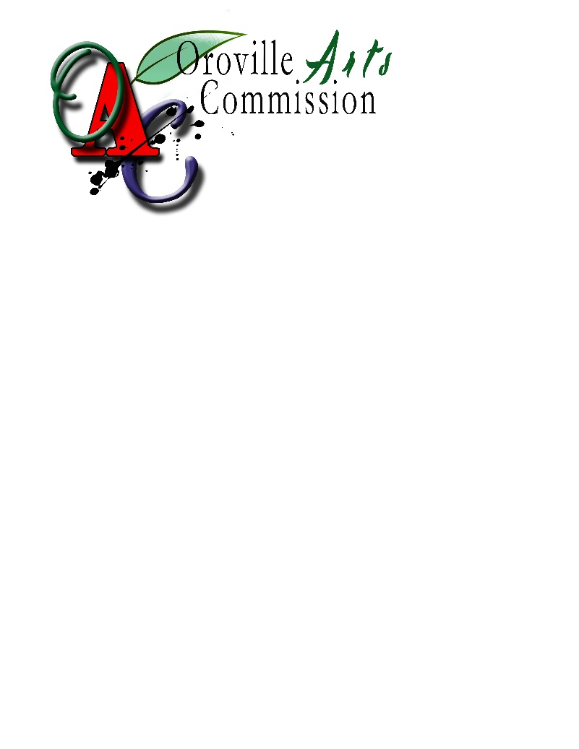

|  |  |
| --- | --- |
| FOR INTERNAL USE ONLY | |
| DATE RECEIVED: |  |
| RECEIVED BY: |  |

**APPENDIX C:**

**PROJECT APPLICATION FORM**

**Oroville Arts Commission**

**2023 Project Application Form**

Art in public places/Oroville beautification

**Estimated Project Cost: $_________________________**

***NOTE:******Please complete all requested information. If the question is not applicable to your request, enter N/A. If additional space is required, please attach additional pages using the format at the end of this application.***

**A. Applicant Information**

1. Name of Applicant and Associated Entity (if any) Legal status

___________________________________________________________

___________________________________________________________

2. Contact Information

a. Mailing address:

___________________________________________________________

b. Telephone, Voice Mail, E-mail Contact Information

___________________________________________________________

**Applicant Acknowledgement and Signature**

**_______________________________________ _______________________**

**Authorized Signature** **Date**

_______________________________________

**Name and Title (Please type or print)**

**B. Description of Project**

***(Briefly summarize the proposed art/beautification and the project benefit if the grant is approved)***

***Project Location: _____________________________________________***

**C. Cost Estimate / Timeline**

***(Provide a cost breakdown of the project. If the project will be completed in phases, please break down the cost by phase; including a final estimate of time and cost. Expand on what each phase will entail.***

*(Please consider site preparation in timeline and cost breakdown.)*

|  |  |  |  |
| --- | --- | --- | --- |
| **Phase** | **Description** | **Estimated Completion**  **Date** | **Phase Cost** |
|  |  |  |  |

**D. Drawings / Renderings of proposed project**

***(Please draw to scale. Attach if necessary)***

**F. Consistency with Arts Commission Goals: (*if not applicable to your request enter N/A)***

Please indicate whether the request is consistent with any of the following Arts Commission Goals. **(Please mark all that apply)**

____ Provides opportunities for the artistic and cultural development of citizens of Oroville.

____ Facilitate the education of all citizens in the development of their creative skills and an appreciation for the arts

____ Support the development of artists and the access and exposure to the community.

____ Consider integrating artists and other design professionals into the planning, design, building, and development of Oroville in order to achieve the highest standards of design for the city.

____ Support diversity in the arts

____ Support a program of “Art in Public Places” as an important component in the

revitalization into a thriving, pedestrian friendly downtown.

____ Promote and support the development of long-term fiscal strategies to assist

local arts organizations in maintaining their stature and contribution to the quality.

**G. Project Selection Criteria**

1. Conceptual compatibility of the design with the immediate environment of the site;
2. Appropriateness of the design to the function of the site;
3. Compatibility of the design and location within a unified design character or historical character of the site;
4. Creation of an internal sense of order and a desirable environment for the general community by the design and location of the work of art;
5. Preservation and integration of natural features with the project;
6. Appropriateness of the materials, textures, colors, and design to the expression of the design concept;
7. Representation of a broad variety of tastes within the community and the provision of a balanced inventory of art in public places to insure a variety of style, design, and media throughout the community that will be representative of the eclectic tastes of the community.

**H.** **Ownership & Maintenance of Art**

**(To be completed by property owner)**

Title to all public art required by and installed pursuant to this section of Per CITY Code §17.08.135(G) on private property shall be vested in the owner and pass to the successive owners of the development project. Each successive owner shall be responsible for the custody, protection and maintenance of such works of art. Public art installed on public property is owned by the City of Oroville and maintenance, removal or protection is the responsibility of the City.

For any works of art installed on private property, the owner(s) of the property shall be required to enter into a written agreement for the maintenance of the artwork. The agreement shall be in a form approved by the City Attorney and Zoning Administrator and suitable for recordation with the Butte County recorder. The agreement shall be binding upon the property owner(s) and any successors in interest. (example agreement attached as Appendix F)

I hereby authorize _______________________________, applicant of the Oroville Arts & Downtown Beautification Program, to create and install a piece of art upon award and acceptance of the Oroville Arts & Downtown Beautification Program grant funding. I further agree, as the property owner, to be responsible for the custody, protection and maintenance of such works of art for the period of time agreed upon between myself and the Arts Commission.

_________________________________

Address of proposed art project

_________________________________ ______________________

Property Owners, Signature Date

________________________________

Property Owners, Print Name

**Send Completed Applications by 4:00 P.M. PST, MOnday, September 18, 2023**

**to:**

City of Oroville

Arts Commission

1735 Montgomery Street

Oroville, Ca 95965

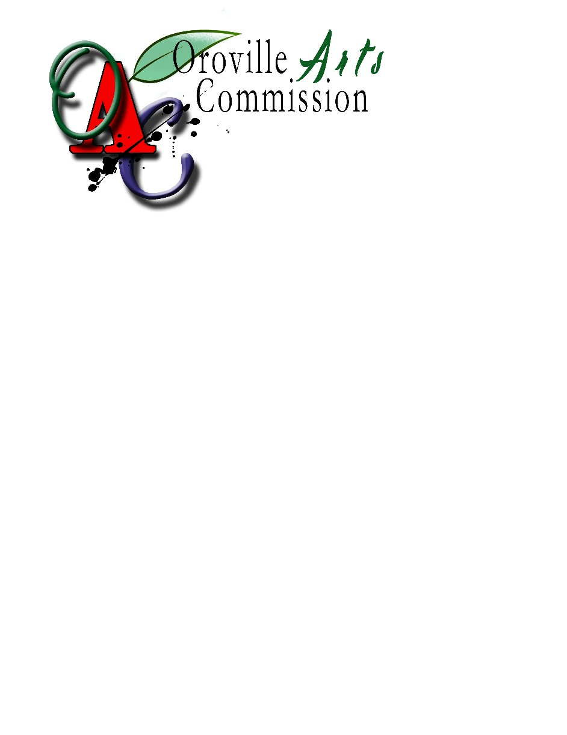

**faxed or electronic copies will not be accepted**

**City of Oroville USE ONLY**

Date Received: _____________________

How Received: _____________________

**Has the applicant provided all information requested in the Preliminary Application?**

____Yes ____No

Notes:

**Record of follow-up:**

Date: ___________________

Issue: Discussed: _______________________________

Date: ___________________

Issue: Discussed: _______________________________

**Copy this page to insert additional information that is expanded beyond the space provided.**

**HEADING: _____________________________________________________**

**Additional information from page # ______________**