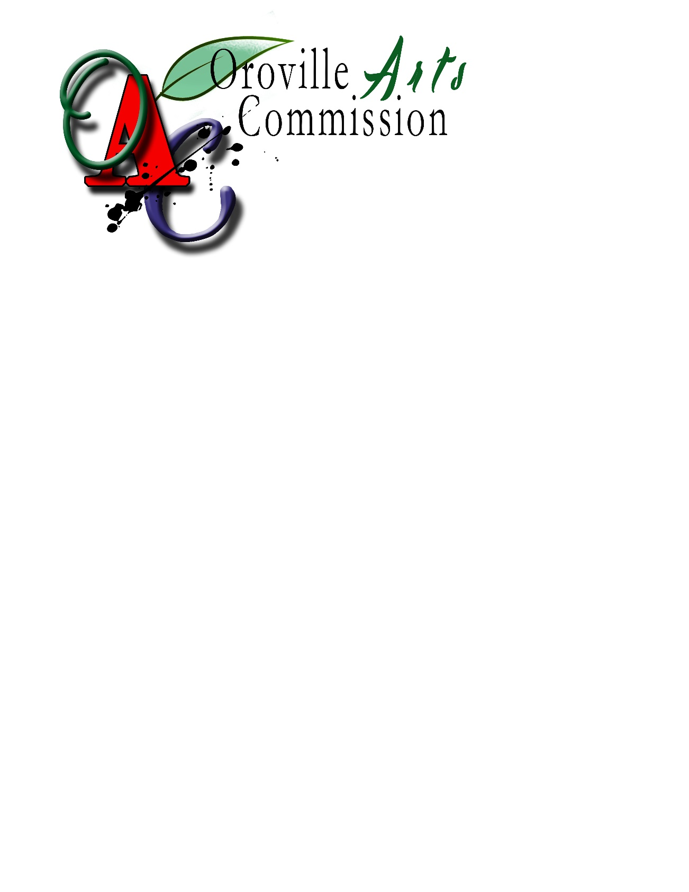

Art in Public Place / Oroville beautification

**NOTICE OF FUNDS AVAILABLE (NOFA)**

**2023 GRANT GUIDELINES & APPLICATION**

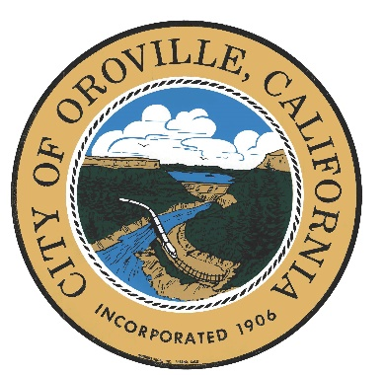

**CITY OF OROVILLE**

#### OROVILLE ARTS COMMISSION

**Date of Release:**

**July 17, 2023**

**Funding provided by**

**Art in Public Places / OROVILLE BEAUTIFICATION REQUIREMENT**

ORDINANCE NO. 1798, APPROVED BY CITY COUNCIL ON AUGUST 20, 2013

**TABLE OF CONTENTS**

|  |  |  |
| --- | --- | --- |
| **Section** | **Topic** | **Page Number(s)** |
|  | Contact Information | 3 |
| I. | Notice of Funds Available (NOFA) | 4 |
| II. | Notice of Funds Available (NOFA) Details | 4 |
| III. | Intent of the Downtown Oroville  Beautification Project | 4 |
| IV. | General Requirements | 4 - 5 |
| V. | Submittal Requirements | 5 - 7 |
| Appendices | (A) Ordinance No. 1798 Art in Public Places / Oroville Beautification  (B) Accounting & Audit Requirements  (C) Project Application Form  (D) Appeal Process  (E) Art Maintenance Agreement (example) | 8  9 - 10  11 - 19  20  21 - 25 |

**Contact Information**

City of Oroville

Community Development Department

Fund Administrator

1735 Montgomery Street

Oroville, Ca 95965

**If you have any questions, please contact:**

**Jordan Daley**

**Phone:** (530) 538-2518

**Email:** jdaley@cityoforoville.org

**Website**: [www.cityoforoville.org](http://www.cityoforoville.org)

The Oroville Arts Commission will hold a two-week Q & A window if there are application process and program requirements questions.



**TUESDAY, AUGUST 7, 2023, through tuesday, august 11, 2023**

**All applicable questions will be answered & posted on the city webpage:**www.cityoforoville.org

**Please send all questions to** [**jdaley@cityoforoville.org**](mailto:ccarmona@cityoforoville.org)

**Send Completed Applications by 4:00 P.M. (PST) monday, september 18, 2023**

**to:**

**City of Oroville**

**Community Development Department**

**Fund Administrator**

**Attention: Jordan Daley**

**1735 Montgomery Street**

**Oroville, Ca 95965**

**faxed or EMAILED copies will not be accepted**

**2021 NOFA Legal Announcement**

1. **NOTICE OF FUNDS AVAILABLE (NOFA)**

The funds are released by the Oroville Arts Commission and the City of Oroville (City), to select a capable and qualified artist to help meet the needs of the Oroville Beautification goals and community involvement plans.

1. **NOTICE OF FUNDS AVAILABLE (NOFA) DETAILS**
   1. Application duration: **60-days from date of release**

(July 19, 2023 – September 18, 2023)

* 1. Funding amount: **$40,000**
     1. May be distributed to fund multiple eligible projects
  2. Project Location: 
     1. Within City Limits
  3. Q & A window: **August 7th – August 11th**

1. **INTENT OF THE OROVILLE BEAUTIFICATION PROJECT**

The purpose is to expand the opportunities for citizens and visitors of the City of Oroville to experience public art and other projects resulting from the creative expression of its visual artists in public places throughout the City. The Public Art / Oroville Beautification Ordinance No. 1798 was established to direct the inclusion of works of art in new non-residential development projects and establishing a fund used solely for the creation, purchase, installation, security and maintenance of art in public spaces throughout the city.

**IV. GENERAL REQUIREMENTS**

The ideal respondent will have knowledge of the Oroville community, history, and culture. The creator of public art shall be a local artist, defined as a person who has a reputation among peers as a person of artistic excellence, through a record of exhibitions, public commissions, sale of works, or educational attainment as judged by the Arts Commission. Public art shall be displayed in a manner that will enhance its enjoyment by the general public.

All amounts collected from the in-lieu fee shall be placed in said Beautification Fund and

expended by the City Administrator or his/her designee solely for the costs associated

with projects that result in the creation, purchase, installation, security or maintenance of art in public spaces that include but are not limited to paintings, mural decorations, inscriptions, stained glass, statues, reliefs or other sculptures, monuments, fountains, arches, or other structures intended for ornament or commemoration, carvings, frescoes, mosaics, or drawings. Furnishing or fixtures affixed to the building or its grounds, including architectural features of the building or landscaping that have been uniquely enhanced to be visually appealing, may qualify as art. Works of art will be permanent.

**V. SUBMITTAL REQUIREMENTS**

The City of Oroville and the Oroville Arts Commission reserves the right to reject any and all proposals submitted, to request clarification of services submitted, to request additional information from competitors, and to waive any irregularity in the proposal and review process. The applicant must submit the following information:

1. **Project Application Submittal**

*Note:* Project elements should be presented in a clear and consistent manner, throughout the application, including scope, timeline, and cost estimates.

*The Grant Application is comprised of the following sections:*

1. Applicant Information
2. Description of Project
3. Project Cost Estimate (with cost breakdown by phase)
4. Timeline to Complete the Project (by phases)
5. Drawings/Renderings of Project to Scale (with incorporation of security device as necessary)
6. Consistency with Arts Commission Goals
7. Project Selection Criteria
8. Ownership & Maintenance of Art
9. Applicant Acknowledgement and Signature

The complete application is in Appendix C, pages 11 – 18. A printable copy of the application is available at [www.cityoforoville.org](http://www.cityoforoville.org) , Government / Boards, Committees, Commissions, etc. / Arts Commission for information and forms. If using additional pages to complete the application, please use the appropriate titles (on each page) as listed above.

1. Arts Commission Review of Applicant’s Project (Screening Process)

The next step involves a technical review of the submitted application considering basic Project Submittal Requirements, Arts Commission Goals and Objectives, and a set of Screening Criteria. On the basis of these considerations, a decision would be made whether or not an application meets minimum requirements. If not, the application would be respectfully rejected. This Initial Screening Process will eliminate projects that lack merit given the seven following considerations:

1. Conceptual compatibility of the design with the exact location within the site;
2. Appropriateness of the design to the function of the site;
3. Compatibility of the design and location within a unified design character or historical character of the site;
4. Creation of an internal sense of order and a desirable environment for the general community by the design and location of the work of art;
5. Preservation and integration of natural features with the project;
6. Appropriateness of the materials, textures, colors, and design to the expression of the design concept;
7. Representation of a broad variety of tastes within the community and the provision of a balanced inventory of art in public places to ensure a variety of style, design, and media throughout the community that will be representative of the eclectic tastes of the community;

An applicant whose Project Concept application does not meet the Initial Screening Criteria has the right to appeal to the Arts Commission, based upon appeal procedures established by the Arts Commission. (see Appendix D, page 19)

3. Staff Assembly and Submittal of Proposed Projects

City of Oroville staff is available for direction to ensure applications are complete and ready for consideration. City of Oroville staff will assemble all project proposals together and prepare packages for the Arts Commission review.

4. Arts Commission Project Selection Process

The Arts Commission will individually be provided a copy of the application, and related attachments, thirty (30) days prior to the applications presentation at a Public Meeting. This provides time for the Arts Commissioners to review the request and formulate questions that they might have.

***5. Timeline Following Arts Commission Screening Process***

1. The Arts Commission selects those applicants that fall within the scope of the project NOFA to move forward for final consideration.
   * 1. 15 Day Appeal process begins.
   1. **No Appeals Received:** Final project application selection announced at the next regularly scheduled Arts Commission meeting (approximately 30 days).
   2. Appeal(s) Received:
      1. **Appeal(s) Received:** Appeals will be heard and considered by the Arts Commission at the next regularly scheduled Arts Commission meeting (approximately 30 days). Final project selection will be announced at the following regularly scheduled Arts Commission meeting (approximately 30 days).
      2. Should an applicant not be satisfied with the Arts Commissions denial of their project application appeal, the applicant may request to be heard by the Executive Committee.
   3. Project Application awarded.

**Appendices**

Appendix A: Ordinance No. 1798 Public Art / Oroville Beautification

Appendix B: Accounting and Audit Requirements

Appendix C: Project Application Form

Appendix D: Appeal Process

Appendix E: Property owner letter and Art Maintenance Agreement (examples)

**Appendix A**

**ORDINANCE NO. 1798**

**ART IN PUBLIC PLACES / OROVILLE BEAUTIFICATION**

***NOTE:******The City Council approved the attached Ordinance No. 1798 Public Art / Oroville Beautification on August 20, 2013.***

(See attached Ordinance No. 1798, pg. 24)

**Appendix B**

**ACCOUNTING AND AUDIT REQUIREMENTS**

**GRANT ADMINISTRATION**

**A.** **Accounting Requirements**

The Grantee must maintain an accounting system that:

* Accurately reflects fiscal transactions, with the necessary controls and safeguards.
* Retain all such documents related to project such as purchase orders, receipts, progress payments, invoices, timecards, canceled checks, etc.
* Provides accounting data so the total cost of each individual project can be readily determined.

**B.** **Records Retention**

Project records must be retained for a period of three (3) years after final payment is made by the Fund Administrator. All project records must be retained by the Grantee at least one (1) year following an audit. Grantees are required to keep source documents for all expenditures related to each grant for at least three (3) years following project completion and one (1) year following an audit. A Project is considered complete upon receipt of final grant payment from the Fund Administrator.

**C. Payment of Grant Funds**

Approved grants require a fully executed Grant Agreement between the Fund Administrator (City of Oroville) and the Grantee. The City of Oroville will provide reimbursement for costs of an approved Grant Agreement as stipulated. All payments are paid on a reimbursable basis. Grantee’s will submit an invoice with appropriate proof of payment (canceled checks, etc.) The Fund Administrator will verify submittals. Once funds are received by the Fund Administrator the Grantee will be issued a check.

1. **Site Visits**

The Fund Administrator, or designee, and an assigned Arts Commissioner will make periodic visits to each Project site, including a final inspection of the site. The Fund Administrator, or designee, will determine if the work is consistent with the approved Public Art / Downtown Beautification Project Scope and ensure compliance with signage requirements that identify the project as a Public Art / Beautification Grant.

* 1. **Loss of Funding**

The following are examples of actions (some or all may apply) that may result in the Grantee’s loss of funding.

* Grantee fails to sign the Grant Contract within the thirty-day time period as specified in the Grant Contract.
* Grantee withdraws from the grant program.
* Grantee fails to complete the funded Project within the agreed upon time frame.
* Grantee fails to submit all documentation within the time periods specified in the Grant Agreement.
* Grantee is unable to acquire any required permits.
* Grantee changes Project Scope, without prior approval from the Arts Commission.

If loss of funding occurs the grantee must return any advanced funds, plus accrued interest (at the current saving rate offered by banks) to the City of Oroville.

|  |  |
| --- | --- |
| FOR INTERNAL USE ONLY | |
| DATE RECEIVED: |  |
| RECEIVED BY: |  |

**APPENDIX C:**

**PROJECT APPLICATION FORM**

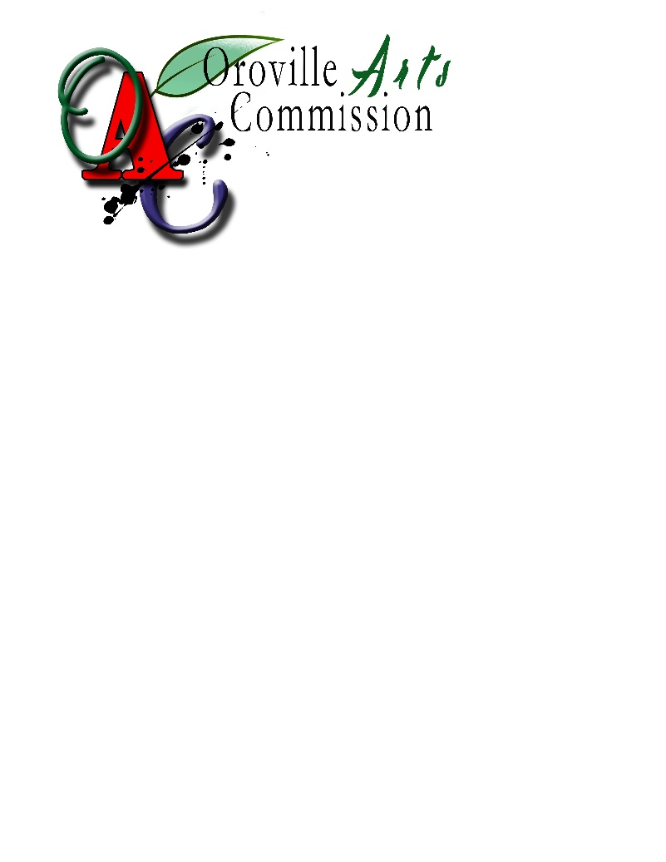

**Oroville Arts Commission**

**2023 Project Application Form**

Art in public places/Oroville beautification

**Estimated Project Cost: $_________________________**

***NOTE:******Please complete all requested information. If the question is not applicable to your request, enter N/A. If additional space is required, please attach additional pages using the format at the end of this application.***

**A. Applicant Information**

1. Name of Applicant and Associated Entity (if any) Legal status

___________________________________________________________

___________________________________________________________

2. Contact Information

a. Mailing address:

___________________________________________________________

b. Telephone, Voice Mail, E-mail Contact Information

___________________________________________________________

**Applicant Acknowledgement and Signature**

**_______________________________________ _______________________**

**Authorized Signature** **Date**

_______________________________________

**Name and Title (Please type or print)**

**B. Description of Project**

***(Briefly summarize the proposed art/beautification and the project benefit if the grant is approved)***

***Project Location:_____________________________________________***

**C. Cost Estimate / Timeline**

***(Provide a cost breakdown of the project. If the project will be completed in phases, please break down the cost by phase; including a final estimate of time and cost. Expand on what each phase will entail.***

*(Please consider site preparation in timeline and cost breakdown.)*

|  |  |  |  |
| --- | --- | --- | --- |
| **Phase** | **Description** | **Estimated Completion**  **Date** | **Phase Cost** |
|  |  |  |  |

**D. Drawings / Renderings of proposed project**

***(Please draw to scale. Attach if necessary)***

**F. Consistency with Arts Commission Goals: (*if not applicable to your request enter N/A)***

Please indicate whether the request is consistent with any of the following Arts Commission Goals. **(Please mark all that apply)**

____ Provides opportunities for the artistic and cultural development of citizens of Oroville.

____ Facilitate the education of all citizens in the development of their creative skills and an appreciation for the arts

____ Support the development of artists and the access and exposure to the community.

____ Consider integrating artists and other design professionals into the planning, design, building, and development of Oroville in order to achieve the highest standards of design for the city.

____ Support diversity in the arts

____ Support a program of “Art in Public Places” as an important component in the

revitalization into a thriving, pedestrian friendly downtown.

____ Promote and support the development of long-term fiscal strategies to assist

local arts organizations in maintaining their stature and contribution to the quality.

**G. Project Selection Criteria**

1. Conceptual compatibility of the design with the immediate environment of the site;
2. Appropriateness of the design to the function of the site;
3. Compatibility of the design and location within a unified design character or historical character of the site;
4. Creation of an internal sense of order and a desirable environment for the general community by the design and location of the work of art;
5. Preservation and integration of natural features with the project;
6. Appropriateness of the materials, textures, colors, and design to the expression of the design concept;
7. Representation of a broad variety of tastes within the community and the provision of a balanced inventory of art in public places to insure a variety of style, design, and media throughout the community that will be representative of the eclectic tastes of the community.

**H.** **Ownership & Maintenance of Art**

**(To be completed by property owner)**

Title to all public art required by and installed pursuant to this section of Per CITY Code §17.08.135(G) on private property shall be vested in the owner and pass to the successive owners of the development project. Each successive owner shall be responsible for the custody, protection and maintenance of such works of art. Public art installed on public property is owned by the City of Oroville and maintenance, removal or protection is the responsibility of the City.

For any works of art installed on private property, the owner(s) of the property shall be required to enter into a written agreement for the maintenance of the artwork. The agreement shall be in a form approved by the City Attorney and Zoning Administrator and suitable for recordation with the Butte County recorder. The agreement shall be binding upon the property owner(s) and any successors in interest. (example agreement attached as Appendix F)

I hereby authorize _______________________________, applicant of the Oroville Arts & Downtown Beautification Program, to create and install a piece of art upon award and acceptance of the Oroville Arts & Downtown Beautification Program grant funding. I further agree, as the property owner, to be responsible for the custody, protection and maintenance of such works of art for the period of time agreed upon between myself and the Arts Commission.

_________________________________

Address of proposed art project

_________________________________ ______________________

Property Owners, Signature Date

________________________________

Property Owners, Print Name

**Send Completed Applications by 4:00 P.M. PST, MONDAY, SEPTEMBER 18, 2023**

**to:**

City of Oroville

Arts Commission

1735 Montgomery Street

Oroville, Ca 95965

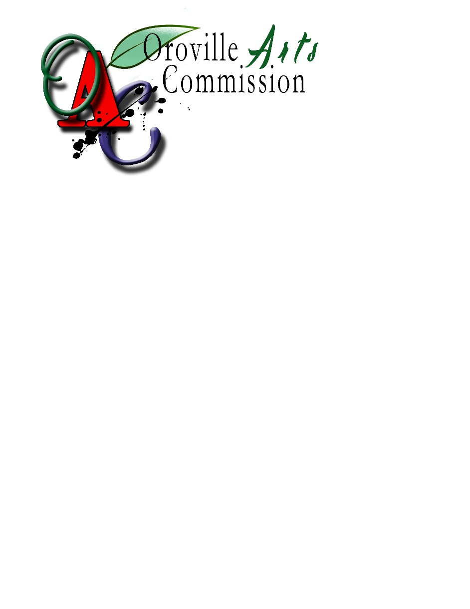

**faxed or electronic copies will not be accepted**

**City of Oroville USE ONLY**

Date Received: _____________________

How Received: _____________________

**Has the applicant provided all information requested in the Preliminary Application?**

____Yes ____No

Notes:

**Record of follow-up:**

Date: ___________________

Issue: Discussed: _______________________________

Date: ___________________

Issue: Discussed: _______________________________

**Copy this page to insert additional information that is expanded beyond the space provided.**

**HEADING: _____________________________________________________**

**Additional information from page # ______________**

**Appendix D**

**The 2023 NOFA Appeal Process**

As part of the Oroville Arts Beautification Program the Oroville Arts Commission established a standardized appeal process for applicants that do not meet the initial screening process. The 2021 NOFA Application combines the initial screening process and formal application into one process. The following details the approved 2021 Appeal Process:

**A.** Appeals to City Council.

1. If the applicant or any other person is dissatisfied with Arts Commission action, he or she may appeal, in writing, to the Executive Committee within 15 days after the action. If no appeal is filed, the Arts Commission’s action shall be final.

2. Within 45 days of the filing of an appeal, the Executive Committee consider the action taken by the Arts Commission and the appeal of that action. The Executive Committee shall render its decision within 30 days of the public hearing, and it shall provide immediate verbal notice of this decision. The decision shall be final.

**B**. Form of Appeals. All appeals shall be submitted in a form established by the zoning administrator, accompanied by a fee established by resolution of the city council. (Ord. 1749 § 4; Ord. 1790 § 2)

**Responses to denial letters must be sent, in writing, to:**

**City of Oroville**

**Community Development Department**

**Fund Administrator**

**Attention: Cecilia Carmona, Administrative Assistant**

**1735 Montgomery Street**

**Oroville, CA 95965**

**Appendix E**

**“No Fee Required”**

**(Govt. Code Sec 6103 & 27383)**

EXAMPLE

**Recorded for the benefit of**

**City of Oroville**

**________________________**

**Authorized Representation**

**AFTER RECORDING RETURN TO:**

**CITY OF OROVILLE**

**CITY CLERK’S OFFICE**

**1735 MONTGOMERY STREET**

**OROVILLE, CA 95965-4897** (SPACE ABOVE FOR RECORDER’S USE)

APN: Address:

**CITY OF OROVILLE**

**OROVILLE ARTS & DOWNTOWN BEAUTIFICATION**

**INSTALLATION AND MAINTENANCE AGREEMENT**

**THIS AGREEMENT** is made this XX day of [Month] 2018, between [Property Owner’s Name] hereinafter referred to as PROPERTY OWNER, add artist???, and the CITY OF OROVILLE, a Municipal Corporation, hereinafter referred to as CITY, for property, located at [Address].

RECITALS

THIS AGREEMENT is based upon the following facts:

1. PROPERTY OWNER is the owner of real property located at [Address] in the City of Oroville described in Exhibit “A” attached to this AGREEMENT and made a part of it by this reference.
2. ARTIST is the _____
3. Per CITY Code §17.08.135(G), for any works of art installed on private property, the PROPERTY OWNER shall be required to enter into a written AGREEMENT for the installation and maintenance of the artwork. The AGREEMENT shall be in a form approved by the CITY Attorney and Zoning Administrator and suitable for recordation with the Butte County recorder. The AGREEMENT shall be binding upon the PROPERTY OWNER and any successors in interest.
4. On [Meeting Date], the City of Oroville Arts Commission reviewed the proposed artwork and forwarded a recommendation to the Oroville City Council for approval.
5. On [Meeting Date], the Oroville City Council reviewed and approved the proposed artwork.

**NOW, THEREFORE, IT IS AGREED BETWEEN THE PARTIES AS FOLLOWS:**

1. PURPOSE. The purpose of this AGREEMENT is to assure that the ARTIST completes the placement of the art in accordance with the approval of the City Council, as specified in Exhibit “B”, and thereafter the PROPERTY OWNER shall maintain and care for the artwork.

2. PROPERTY SUBJECT TO AGREEMENT. The property subject to this AGREEMENT is described in Exhibit “A” attached to this AGREEMENT and incorporated in it by this reference:APN: **(XXX-XXX-XXX).**

3. DUTY TO INSTALL AND MAINTAIN ARTWORK. ARTIST agrees to complete the installation of the CITY approved artwork. The ARTIST and the PROPERTY OWNER shall diligently maintain and care for the artwork which they install under this AGREEMENT, using generally accepted methods of placement and care. PROPERTY OWNER and/or ARTIST shall maintain that standard of care necessary to prevent the artwork from deteriorating to the extent that its value as artwork is destroyed.

4. CITY MAY MAINTAIN ARTWORK. PROPERTY OWNER agrees that if they fail to meet the standard of maintenance necessary to keep the artwork in a properly maintained condition, CITY will give written notice of the deficiency to the PROPERTY OWNER, who shall have twenty (20) days to make the necessary correction and, if the correction is not made within twenty (20) days, CITY may elect to take the steps necessary to assure that the artwork is maintained and cared for. To do this, CITY shall serve a notice to the PROPERTY OWNER of its intent to enter the premises for this purpose. CITY shall either personally serve the notice to PROPERTY OWNER or mail a copy of it by certified mail to the PROPERTY OWNER’S address, as shown in paragraph 7 below, at least fifteen (15) days in advance of the date CITY intends to enter the premises.

5. CITY’S COST OF MAINTAINING A LIEN. If the CITY incurs costs in restoring or maintaining the artwork after following the procedure set forth in Paragraph 4 above, CITY shall make demand upon PROPERTY OWNER for payment. If PROPERTY OWNER fails to pay the costs incurred by CITY within thirty (30) days of the date demand was made, CITY may impose a lien upon the real property described in Exhibit “A” by recording a notice that CITY has incurred expenses under the terms of this AGREEMENT with the County Recorder of Butte County. Such notice shall state the fact that CITY has incurred costs under the terms of this AGREEMENT and shall state the amount, together with the fact that it is unpaid and draws interest at the rate of 7% (percent) a year until paid.

6. ADDITIONAL REMEDIES. CITY may, as an alternative to the lien procedure, set forth in Paragraph 5 above, bring legal action to collect the sums due as the result of making expenditures for restoration and maintenance of artwork. PROPERTY OWNER agrees to pay CITY a reasonable sum of attorney fees and court costs, together with interest from the date which is thirty (30) days after CITY has given its notice under Paragraph 5 above.

7. NOTICES. Notice given by each party to this AGREEMENT shall be given to the other party at the addresses shown below:

CITY: City of Oroville

1735 Montgomery Street

Oroville, CA 95965-4897

PROPERTY OWNER: [Name and Address]

8. ADDITIONAL REQUIREMENTS.

The PROPERTY OWNER hereby agrees to the following:

1. Warrants that the artwork created and installed is a faithful rendition of the artwork as approved by the CITY.
2. Shall ensure that any artwork approved by the CITY is provided with adequate scheduled routine maintenance necessary to maintain a neat and attractive appearance.
3. f. To prevent materials and other deleterious materials from entering CALTRANS drainage gutters, drainage outlets and storm drain pipes.To expeditiously maintain, replace, or repair any artwork that has become unsafe or unsightly, or within 20 days when notified in writing that maintenance, replacement, or repair is required.
4. To allow random inspection of artwork by a CITY representative.
5. To keep all artwork policed and free of litter and deleterious material.
6. All work by or on behalf of PROPERTY OWNER will be done at no cost to the CITY.
7. The artwork shall remain in substantial conformance as approved by the Oroville City Council. Any subsequent minor changes in the project (as determined by the Zoning Administrator) may only occur subject to the review and approval of the Oroville Arts Commission. Any subsequent substantive changes in the project (as determined by the Zoning Administrator) may only occur subject to the review and approval by the Oroville City Council.
8. Removal of artwork under this agreement shall be removed as specified under §17.08.135(I) of the Oroville Municipal Code.

9. MISCELLANEOUS TERMS AND PROVISIONS.

a. If any provision of this AGREEMENT is adjudged invalid, the remaining provisions are not affected.

b. Notice to PROPERTY OWNER will be considered to have been given to them when sent to their address stated above (Paragraph 7).

c. This writing contains a full, final, and exclusive statement of the AGREEMENT between the parties.

d. If there is more than one signer of this AGREEMENT as PROPERTY OWNER(S), their obligations are joint and several.

e. The obligations upon the PROPERTY OWNER(S) signing this AGREEMENT terminate personally as to them when they convey their interest in the property and files for record with the County Recorder a copy of assignment to this AGREEMENT. In this case, the new PROPERTY OWNER(S) takes title subject to the requirements of this AGREEMENT.

f. If the installation of the work of art is delayed by adverse weather conditions, or any other cause beyond the PROPERTY OWNER’S reasonable control, then the installation date shall be extended for such reasonable time as agreed upon by all parties to this AGREEMENT.

g. PROPERTY OWNER agrees to comply with all federal and state laws, and local ordinances that pertain to the creation and installation of the artwork.

h. In the event of litigation relating to this AGREEMENT, the prevailing party shall be entitled to receive attorney’s fees from the losing party.

10. AGREEMENT ATTACHED TO THE LAND. This AGREEMENT pertains to and runs with the real property described in Exhibit “A”. This AGREEMENT binds the successors in interest of each of the parties to such real property.

CITY OF OROVILLE: BY: /s/ _________________________________

Brian Ring, City Administrator

DATE: _________________________________

PROPERTY OWNER: BY: /s/ _________________________________

PRINTED NAME: __________________________________

PROPERTY OWNER: BY: /s/ _________________________________

PRINTED NAME: __________________________________

A Public Notary must acknowledge PROPERTY OWNERS’ and CITY’S signatures. If PROPERTY OWNER is a corporation, partnership, or other business entity, the Notary must acknowledge the signature as well as the person’s relationship to the business.

EXHIBIT “A”

A LEGAL DESCRIPTION OF SAID PROPERTY MUST ACCOMPANY THIS AGREEMENT AS EXHIBIT “A” PRIOR TO RECORDATION (PROVIDED BY PROPERTY OWNER)

EXHIBIT “B”

THIS AGREEMENT SHALL ACCOMPANY THE OROVILLE ARTS & BEAUTIFICATION APPLICATION THAT CONTAINS A DETAILED DESCRIPTION OF THE ARTWORK, INCLUDING DRAWINGS WITH DIMENSIONS, DESCRIPTION OF MATERIALS, AND CONSIDERATIONS FOR LONGEVITY, CONSERVATION AND MAINTENANCE AS APPROVED BY THE CITY COUNCIL MUST ACCOMPANY THIS AGREEMENT