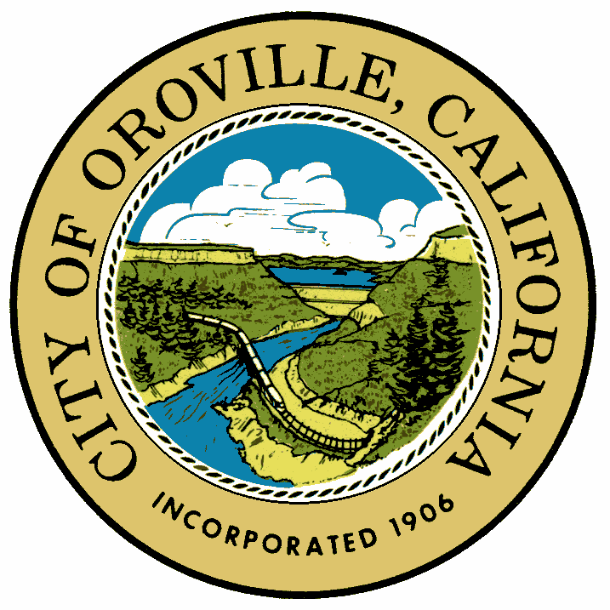

**CITY OF OROVILLE**

**1735 MONTGOMERY STREET ● OROVILLE, CA 95965-4897**

**530-538-2535**

**Fax 530-538-2468**

**PRESS RELEASE**

**OROVILLE ART’S COMMISSION**

**ANNOUNCES 2023 GRANT AVAILABILITY**

**OROVILLE, CA** **– July 17, 2023 –**The Arts Commission has released a $40,000 Arts in Public Places, Beautification NOFA (may be distributed to fund multiple eligible projects). Application period began July 19, 2023 and closes September 18, 2023 at 4:00 p.m.

The purpose is to expand the opportunities for citizens and visitors of the City of Oroville to experience public art and other projects resulting from the creative expression of its visual artists in public places throughout the City. The Public Art / Oroville Beautification Ordinance No. 1798, was established to direct the inclusion of works of art in new non-residential development projects and establishing a fund used solely for the creation, purchase, installation, security and maintenance of art in public spaces throughout the city.

The Arts Commission is open to all locations within City limits. Artists are welcome to submit applications highlighting their medium of choice. Visit the City of Oroville website for specific Art in Public Places / Oroville Beautification funding details.

A Q & A window will be held on Tuesday, August 7th, 2023, until Tuesday, August 11th, all applicable questions will be answered and posted on the city webpage. Please send all questions to [jdaley@cityoforoville.org](mailto:jdaley@cityoforoville.org)

-XXX-

**For Immediate Release**

Press Release Contact:

Jordan Daley

City of Oroville

(530) 538-2518

[jdaley@cityoforoville.org](mailto:ccarmona@cityoforoville.org)